Without refresh page, faster than angular

React is javascript library for building user interfaces.

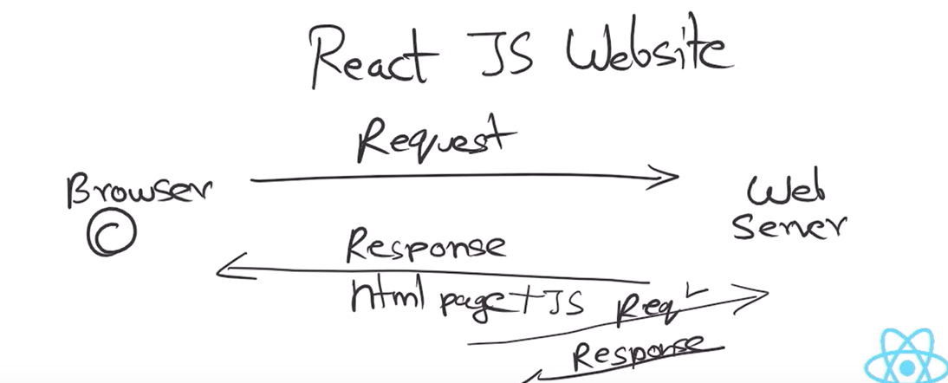

Javascript will request web server for furhter data without refresh page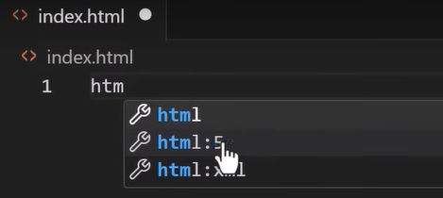

react cdn links

babel cdn

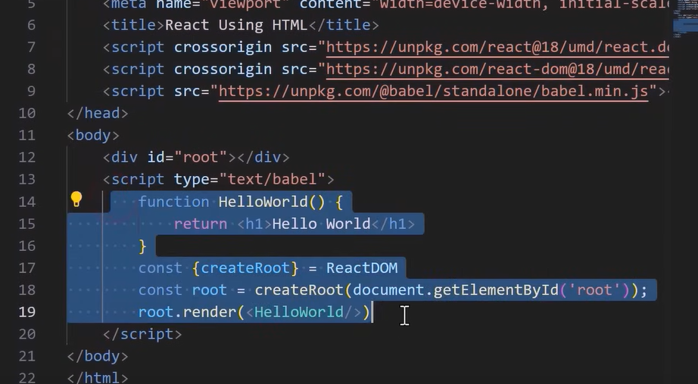

Node.js run time environment.

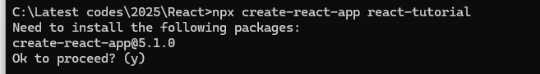

Npm start

Webpack convert all react code to pure javascript

JSX javascript xml

All react xml converted into normal javascript. In bundle.js file

